Unit 1 Links to Kahoots and Unit Tests

Mission 1, 2, 3 | https://create.kahoot.it/share/firia-labs-ap-csp-mission-1-2-3/5be3baab-3370-49ae-8912-adf30394f2bd
Mission 4 | https://create.kahoot.it/share/firia-labs-mission-4/98961e05-e6e6-435a-90ca-0f01a2d757ef
Mission 5 | https://create.kahoot.it/share/firia-labs-mission-5/9b0dba3c-afa2-4174-8af7-e227b949e3bf
Unit 1 Vocabulary Review | https://create.kahoot.it/share/firia-labs-unit-1-vocab-review/c410d2b9-12f9-4708-bd82-46c685a48652
Unit 1 Coding and Concepts Review | https://create.kahoot.it/share/firia-labs-unit-1-code-review/0b570dec-fb94-4350-856d-4246c59ba0d7
Unit 1 Vocabulary Exam (MS Form) | https://forms.office.com/Pages/ShareFormPage.aspx?id=DQSIkWdsW0yxEjajBLZtrQAAAAAAAAAAAAO__SjBvJpUQzlYRUdYUzQyMldRODgzRUZHVzJUSzFFSy4u&sharetoken=tDTG96CmUc8q3KXIp3X7
Unit 1 Coding and Concepts Exam (MS Form) | https://forms.office.com/Pages/ShareFormPage.aspx?id=DQSIkWdsW0yxEjajBLZtrQAAAAAAAAAAAAO__SjBvJpUQzg1NDZESDgxUTVJN01ORUtLVUVBTkZBRi4u&sharetoken=ODTUi2geoYjKxOC6yYdd

Unit 1 Question Bank: Kahoot Reviews and Microsoft Forms Exams

Missions 1, 2 & 3 Kahoot Review
What is a “bug”? | - A moth in a computer  - An error in the code, like a typing mistake  - A creeping thing with several legs  - When your program runs slowly
What is “CPU”? | - The brain of the computer  - The center intelligence agency  - The keyboard, printer and screen  - The hardware of the computer, like the tower and cables
What is “peripheral”? | - The hardware of the computer, like the case and cables  - The brain of the computer  - A problem with the code that needs to be fixed  - Devices that interact with the CPU
What is “RGB”? | - The peripherals needed on a computer – keyboard, screen, printer  - The brain of the computer  - The lights in a pixel that can create all colors  - A debugging technique while coding
What is “sequencing”? | - Executing two lines of code at the same time  - Executing code one line at a time in order  - A name for any value, used throughout a program  - A specific value, like 1 or “hello”
What is “literal”? | - Similar to peripheral, it is a device  - A name for any value, used throughout a program  - A type of data that can be stored  - A specific value, like 1 or “hello”
What is “variable”? | - Similar to peripheral, it is a device  - A name for any value, used throughout a program  - A type of data that can be stored  - A specific value, like 1 or “hello”
What line of code defines a variable? | - delay  - delay = 1  - 1  - define delay
What does this code do? | - Puts the CPU in sleep mode for 1 second  - Delays program execution for 1 second  - Assigns the value 1 to the variable delay  - Sets the parameter to 1
What does this code do?  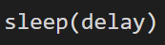 | - Puts the CPU in sleep mode for 1 second  - Delays program execution “delay” seconds  - Delays program execution for 1 second  - Causes an error

Mission 4 Kahoot Review
What is an “argument”? | - A built-in function that converts one type to another  - A decision point in code; a branch  - Information passed to a function so it can complete its task  - Structuring a block of code by indenting 4 spaces
What is “selection”? | - A built-in function that converts one type to another  - A decision point in code; a branch  - Information passed to a function so it can complete its task  - Structuring a block of code by indenting 4 spaces
What is the argument in the code?  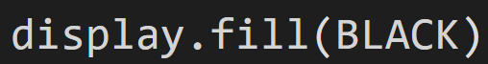 | - display  - fill  - BLACK  - There isn’t one
What is the best data type for this value: “hello” | - Integer  - String  - Boolean  - CodeX image
What is the best data type for this value: pics.PLANE | - Integer  - String  - Boolean  - CodeX image
What is the best data type for this value: 42 | - Integer  - String  - Boolean  - CodeX image
What is the best data type for this value: True | - Integer  - String  - Boolean  - CodeX image
What is the result if the user presses button A?  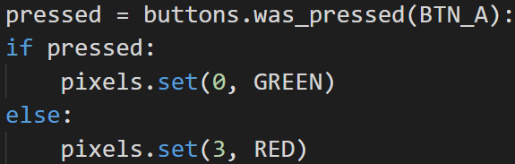 | - The first pixel turns GREEN  - The first pixel turns RED  - The last pixel turns RED  - The first pixel turns GREEN and the last pixel turns RED
What is the result if the user presses button A?  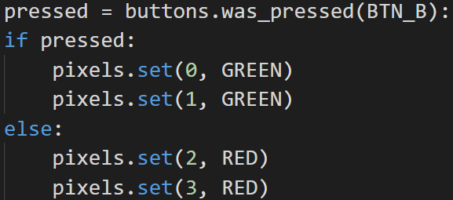 | - The first two pixels turn GREEN  - Each of the pixels will flash a color  - The last two pixels turn RED  - The first pixels turn GREEN and the last pixels turn RED
What is the result if the user presses button A?  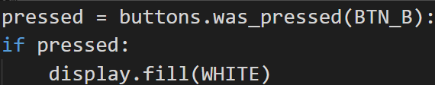 | - The display screen turns WHITE  - The display screen turns BLACK  - Nothing will happen; the block is skipped  - An error

Mission 5 Kahoot Review
What is “analog”? | - Making the code readable by adding blank lines and comments to the code  - Smooth and continuous signals that represent a quantity, like sound waves  - Creating and using functions in the program so the code can be reused  - A numeric representation of an analog signal, represented in increments
What is “digital”? | - Making the code readable by adding blank lines and comments to the code  - Smooth and continuous signals that represent a quantity, like sound waves  - Creating and using functions in the program so the code can be reused  - A numeric representation of an analog signal, represented in increments
What is “readability”? | - Adding blank lines and comments to code so it is easy to understand  - Notes in code that explain what the code does; ignored by the computer  - Creating and using functions in the program so the code can be reused  - A numeric representation of an analog signal, represented in increments
What are “comments”? | - Adding blank lines and comments to code so it is easy to understand  - Notes in code that explain what the code does; ignored by the computer  - Creating and using functions in the program so the code can be reused  - A numeric representation of an analog signal, represented in increments
What is an example of a multiline comment? | - 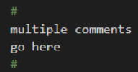 C,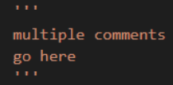  - 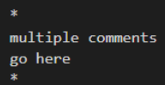 D.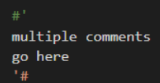
What does the “import” command do?  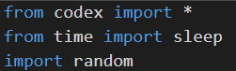 | - Allows you to use the CodeX, time and random numbers  - Moves the code to a different programming environment  - Provides access to pre-built functions and methods in coding libraries  - Enables object-oriented programming
Which is NOT something that makes your code more readable? | - Short variable names, like ‘ab’ or ‘xy’  - Comments that explain the code  - Consistent 4-space indenting in code blocks  - Blank lines separating sections of code
What does this line of code do? | - Plays the audio file “roll”  - Assigns the value “sounds/roll” to a variable named ‘play_it’  - Uploads the audio file ‘roll’ into the CodeX sounds folder  - Causes an error
This code segment is an example of: 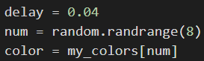 | - Randomization  - Selection  - Sequencing  - Iteration
This code segment is an example of: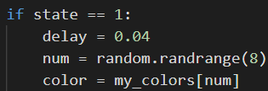 | - Randomization  - Selection  - Sequencing  - Iteration

Additional questions are provided below for the supplemental lessons: Defining Functions and RGB colors

Unit 1 Vocabulary (Kahoot Review and Unit 1 Exam)
Select the best computer science definition for each vocabulary word
Code | - Where you type a program  - Instructions to the computer  - A secret password  - A way to hide a message
Bug | - An error in the code; like a typing mistake  - When your program runs slowly  - A moth that gets stuck in a computer  - When your program never stops
CPU | - A debugging technique  - The program you write  - The devices you attach to CodeX  - The brain of the computer that runs code
Literal | - A name for a value; used throughout a program  - It is a device, like a peripheral  - A specific value, like 1 or “hello”  - A type of data that can be stored
Variable | - A name for a value; used throughout a program  - It is a device, like a peripheral  - A specific value, like 1 or “hello”  - A type of data that can be stored
RGB | - The devices attached to CodeX  - A debugging technique  - The colors that make up a single pixel  - The “brain” of the computer
Sequential | - A decision point in code; has a condition  - Repeating a block code, subject to a condition  - An expression that evaluates to True or False  - Code that runs one line after another in order
Branching | - A decision point in code; has a condition  - Repeating a block code, subject to a condition  - An expression that evaluates to True or False  - Code that runs one line after another in order
Readability | - Notes in code that explain what the code does, ignored by the computer  - Creating and using functions so the code can be reused  - A numerical representation of an analog signal, represented in increments  - Adding blank lines and comments to code so it is easy to understand
Comments | - Notes in code that explain what the code does, ignored by the computer  - Creating and using functions so the code can be reused  - A numerical representation of an analog signal, represented in increments  - Adding blank lines and comments to code so it is easy to understand

Unit 1 Concepts and Coding (Kahoot Review)
What does this code do? | - Turns on the CodeX LEDs  - Imports the * from CodeX  - Provides access to built-in Codex code  - Moves the code to computer memory
What does this code do?  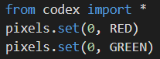 | - Turn pixel 0 RED for 1 second and then GREEN for 1 second  - Turn pixel 0 RED very quickly and then GREEN  - Turn pixel 0 GREEN  - Turn pixel 0 RED
What does this code do?  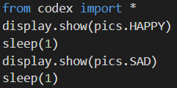 | - Display HAPPY for 1 second and then SAD for 1 second  - Display HAPPY very quickly and then display SAD  - Display only the SAD image  - Display only the HAPPY image
What does this code do? | - Puts the CPU in sleep mode for 1 second  - Pauses program execution for 1 second  - Assigns the value 1 to the variable delay  - Sets the sleep to 1
What does this code do? | - Puts the CPU in sleep mode for 1 second  - Pauses program execution “delay” seconds  - Assigns sleep the value delay  - Causes an error
Which function will change an integer to a string? | - str(15)  - int(15)  - string(15)  - 15.str()
What is the result if the user presses button A?  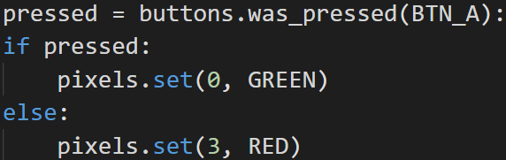 | - The first pixel turns GREEN  - The first pixel turns RED  - The last pixel turns GREEN  - The first pixel turns GREEN and the last pixel turns RED
What is the result if the user presses button A?  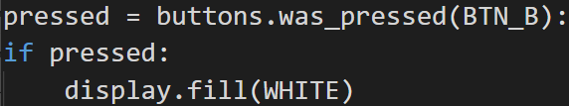 | - The display screen turns WHITE  - The display screen turns BLACK  - Nothing will happen; the block is skipped  - An error
What does this line of code do? | - Plays the audio file “roll”  - Assigns the value “sounds/roll” to a variable named ‘play_it’  - Uploads the audio file ‘roll’ into the CodeX sounds folder  - Causes an error
What does this line of code do? | - Plays the audio file “roll”  - Assigns the value “sounds/roll” to a variable named ‘play_it’  - Uploads the audio file ‘roll’ into the CodeX sounds folder  - Causes an error
This code segment is an example of: | - Randomization  - Selection  - Sequencing  - Iteration
This code segment is an example of: | - Randomization  - Selection  - Sequencing  - Iteration
What is the data type of this value: ‘CodeX’ | - Integer  - Float  - String  - Boolean
What is the data type of this value: 3.1416 | - Integer  - Float  - String  - Boolean
What is the data type of this value: False | - Integer  - Float  - String  - Boolean

Unit 1 Concepts and Coding (Unit 1 Exam)
What does this code do?  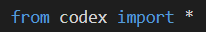 | - Turns on the CodeX LEDs  - Provides access to built-in CodeX code  - Moves the code to computer memory  - Imports * from CodeX
What does this code do?  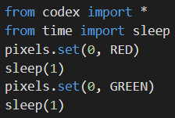 | - Pixel 0 turns RED for 1 second and then GREEN for 1 second  - Pixel 0 turns RED very quickly and then GREEN  - Pixl 0 turns GREEN  - Pixel 0 turns RED
What does this code do?  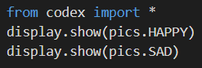 | - Displays HAPPY image for 1 second and then SAD image for 1 second  - Displays HAPPY image very quickly and then SAD image  - Display only the SAD image  - Display only the HAPPY image
What does this code do?  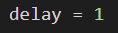 | - Assigns the value 1 to the variable “delay”  - Sets the sleep to 1  - Pauses program execution for 1 second  - Puts the CPU in sleep mode for 1 second
What does this code do?  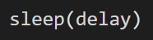 | - Assigns the variable “sleep” the value “delay”  - Causes an error  - Pauses program execution for “delay” seconds  - Puts the CPU in sleep mode for “delay” seconds
Which function will change (or convert) an integer to a string? | - int(4)  - str(4)  - string(4)  - str = “4”
What is the result if the user presses BUTTON B?  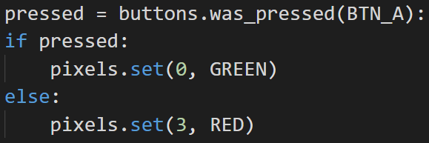 | - The first pixel turns GREEN  - The first pixel turns RED  - The last pixel turns RED  - The first pixel turns GREEN and the last pixel turns RED
What is the result if the user pressed BUTTON B?  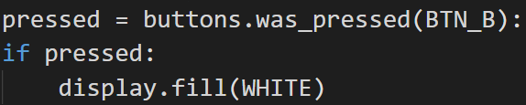 | - The display screen turns WHITE  - The display screen turns BLACK  - Nothing will happen; the block is skipped  - An error
What does this code do?  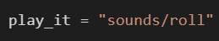 | - Plays the audio file “roll”  - Assigns the value “sounds/roll” to the variable “play_it”  - Uploads the audio file “roll” into the CodeX sounds folder  - Causes an error
What does this code do?  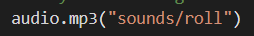 | - Plays the audio file “roll”  - Assigns the value “sounds/roll” to the variable “play_it”  - Uploads the audio file “roll” into the CodeX sounds folder  - Causes an error
The code is an example of:  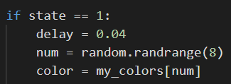 | - Sequencing  - Selection  - Randomization  - Iteration
The code is an example of:  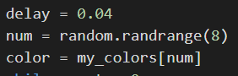 | - Sequencing  - Selection  - Randomization  - Iteration
What is the data type of this value: 12 | - Float  - String  - Integer  - Boolean
What is the data type of this value: True | - Float  - String  - Integer  - Boolean
What is the data type of this value: “coding” | - Float  - String  - Integer  - Boolean

Questions for Supplemental Lessons
Vocabulary: Select the best computer science definition for each vocabulary word
Function | - The kind of information stored in a variable  - The process of removing characteristics to focus on essential elements  - An expression that evaluates to True or False  - A named set of instructions that accomplishes a task
Abstraction | - The kind of information stored in a variable  - The process of removing characteristics to focus on essential elements  - An expression that evaluates to True or False  - A named set of instructions that accomplishes a task
tuple | - A little more than a triple  - A type of decision structure  - The data type of a triplet  - The value passed to a parameter
Coding and Concept Questions
Which is NOT a reason to create a function? | - Simplify code  - Prevent the user from changing the code  - Eliminate duplicate code  - Make a section of code adaptable
What line of code creates a function? | - def new_function():  - new_function():  - new_function()  - def new_function
What line of code calls a function? | - def new_function():  - new_function():  - new_function()  - def new_function
In this RGB triplet, which color is 100?  my_color = (50, 100, 150) | - RED  - GREEN  - BLUE  - YELLOW
What line of code assigns a tuple to a variable? | - new_var = RGB  - new_var = 100  - new_var = pixels.set()  - new_var = (47, 52, 145)
In this line of code, the 10 represents: | - The pixel to light  - The amount of GREEN  - The brightness  - The color
The indicted numbers in the line of code are:  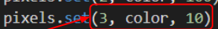 | - Arguments  - Parameters  - Functions  - A tuple
What are the possible values of rand_num? | - All numbers between 1 and 10  - Integers between 0 and 9  - Integers between 1 and 10  - Either a 0 or a 10
What line of code will generate a random number between 1 and 100? | - rand_num(100)  - rand_num = randrange(1, 101)  - rand_num = randrange(100)  - rand_num = randrange(1, 100)
What line of code will turn off the first pixel? | - pixels.set(0, BLACK)  - pixels.set(0, OFF)  - pixels.off(0)  - pixels.set(OFF, 0)

